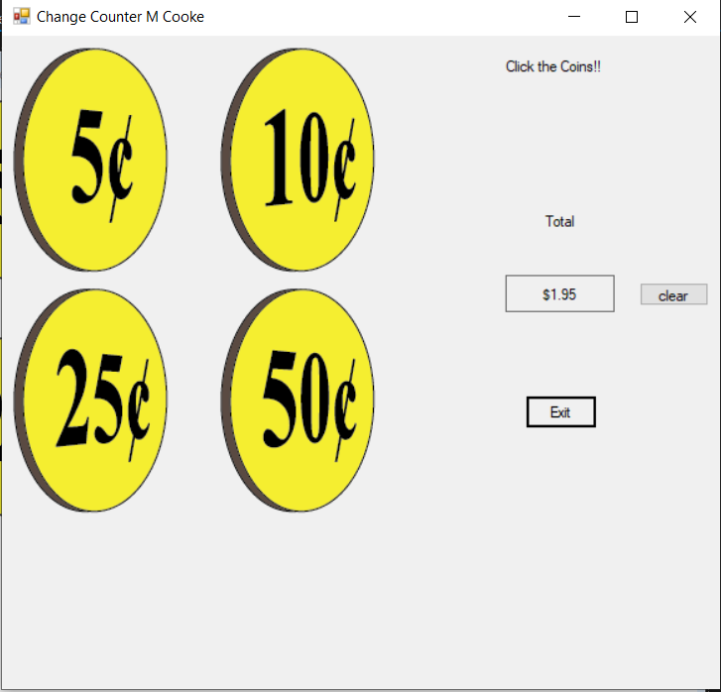

namespace Change_Counter

{

public partial class Form1 : Form

{

// initialize the constant fields

decimal FIVE_CENTS_VALUE = .05m;

decimal TEN_CENTS_VALUE = .1m;

decimal TWENTY_FIVE_CENTS_VALUE = .25m;

decimal FIFTY_CENTS_VALUE = .50m;

//field variable to hold the total for the screen

private decimal total = 0m;

public Form1()

{

InitializeComponent();

}

private void exitButton_Click(object sender, EventArgs e)

{

//closes program

this.Close();

}

private void fiveCentsPictureBox_Click(object sender, EventArgs e)

{

//adds 5 cents to the total

total += FIVE_CENTS_VALUE;

//sets new total to the value of the totalLabel

totalLabel.Text = total.ToString("c");

}

private void tenCentsPictureBox_Click(object sender, EventArgs e)

{

//adds 10 cents to the total

total += TEN_CENTS_VALUE;

//sets new total to the value of the totalLabel

totalLabel.Text = total.ToString("c");

}

private void twentyFiveCentsPictureBox_Click(object sender, EventArgs e)

{

//adds 25 cents to the total

total += TWENTY_FIVE_CENTS_VALUE;

//sets new total to the value of the totalLabel

totalLabel.Text = total.ToString("c");

}

private void fiftyCentsPictureBox_Click(object sender, EventArgs e)

{

//adds 50 cents to the total

total += FIFTY_CENTS_VALUE;

//sets new total to the value of the totalLabel

totalLabel.Text = total.ToString("c");

}

private void clearButton_Click(object sender, EventArgs e)

{

//wanted to add a clear button jsut because

totalLabel.Text = "";

}

}

}